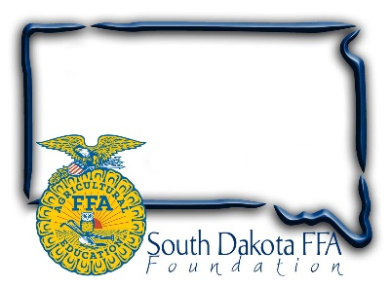
FOR IMMEDIATE RELEASE

September 30, 2024

Contact:
Gerri Eide
SD FFA Foundation
gerri@sdffafoundation.org
605-765-4865
**FOR IMMEDIATE RELEASE**

South Dakota FFA Foundation Partners with Bloom to Launch A SOCKTOBER Sock Store to Support Service!

(Bath, SD —Sept 2024)— LIVING TO SERVE is the 4th line in the FFA motto, and the SD FFA Socktober sock sale is all about service! The SD FFA Foundation, partnered with Bloom, a mission-based fundraising company that supports youth in agriculture and is the American leader in ag-themed socks, are excited to launch a Socktober Sock Store. The Socktober Store will launch October 1st, with an online store that makes purchasing fun socks and gifts for others easy. All profits will be used to grow the impact of the SD FFA Convention Day of Service meal packaging event.

Buy just one pair of socks for yourself, as a gift, or stick to the service theme by donating them to a shelter, and you also feed 15 people an additional meal. Our Socktober goal is to raise an additional $2000 so we can package an extra 5,500 Meals of Hope during our State Convention, which we will donate to Feeding South Dakota. We have 8 Sock options to choose from, which include fun holiday designs and Ag/FFA designs, which are perfect for stocking stuffers or gifts. Bloom socks are made 100% in the United States and are cross knitted for premier stretch. Socks sell for $12.95 and ship directly to your home! Through October 31st only, so buy now!

“We are excited about this collaboration with Bloom, which aligns perfectly with our goals of supporting agricultural education and fostering leadership among youth,” said Gerri Ann Eide, Executive Director of the South Dakota FFA Foundation. “This initiative provides a unique fundraising opportunity and promotes our living to serve mission.”

Please visit our SOCKTOBER STORE for more information about SOCKTOBER and how to support South Dakota FFA’s Day of Service Project.

About Bloom:
Bloom is dedicated to providing fundraisers that support the growth of youth agriculture. They are committed to helping expand resources and enhance their brand through innovative and effective fundraising programs.

About South Dakota FFA Foundation:
The South Dakota FFA Foundation supports the mission of the South Dakota FFA Association by providing resources, scholarships, and opportunities for students involved in agricultural education. The foundation is committed to developing the next generation of agricultural leaders.

